**Capstone Project: Summary Report**

**Explore the Data**: Use descriptive statistics to provide an overview of the data.

**Key Questions**:

**What are the most common diagnoses based on region?**

For the males, it is Diabetes while for the Females it is Arthritis.

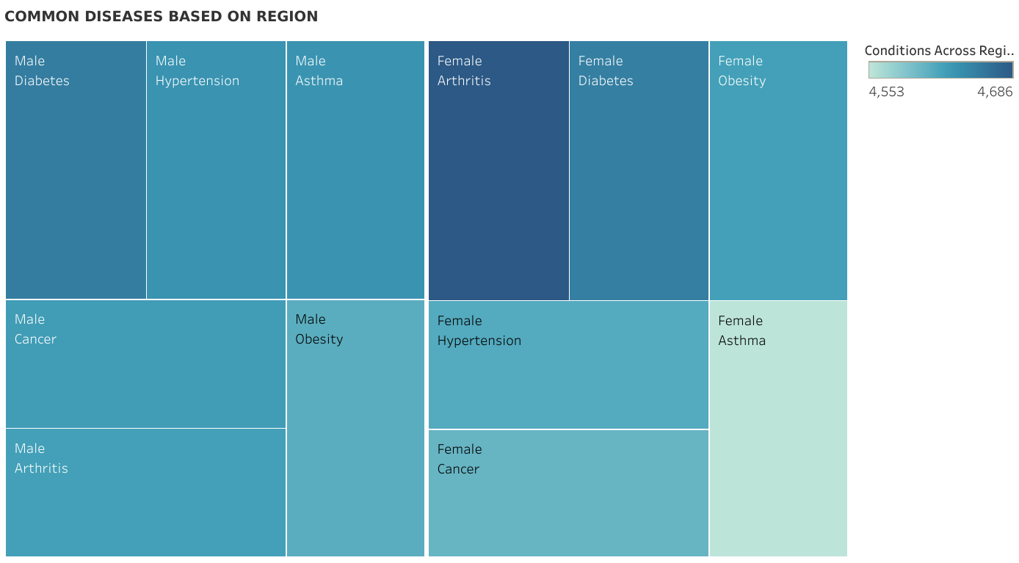

**What are the success rates of the various treatment plans?**

There is a generally high success rate of diagnosing illnesses with with a 33% chance of it being Inconclusive. This may or may not be a cause for worry as it simply means that the patient needs to be further tested to get a correct diagnosis.

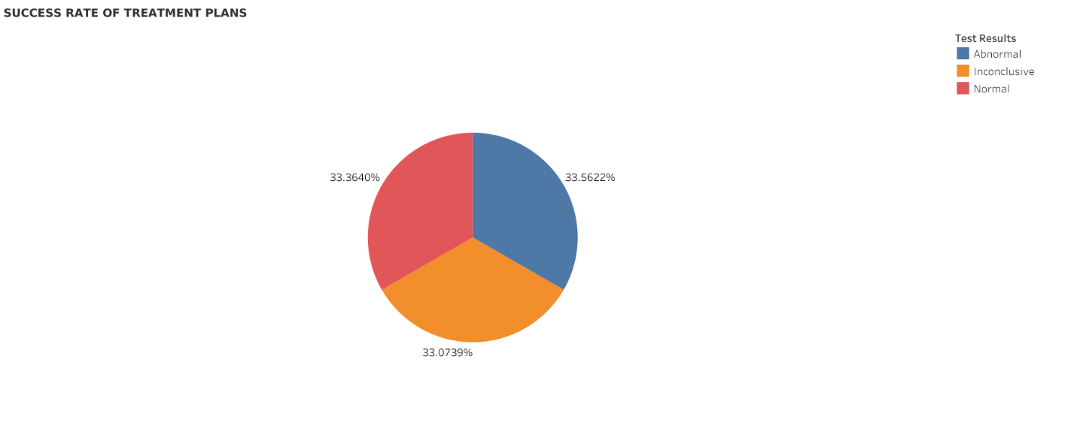

**What are the demographics (age, gender) of patients with specific health conditions?**

It seems as both the male and female genders grow, they are at significant risk of being diagnosed with a disease that poses a risk to their life. It starts from the early 20s and actively progresses to old age. This may also be an indicator that the disease might either be inherited or bad lifestyle choices.

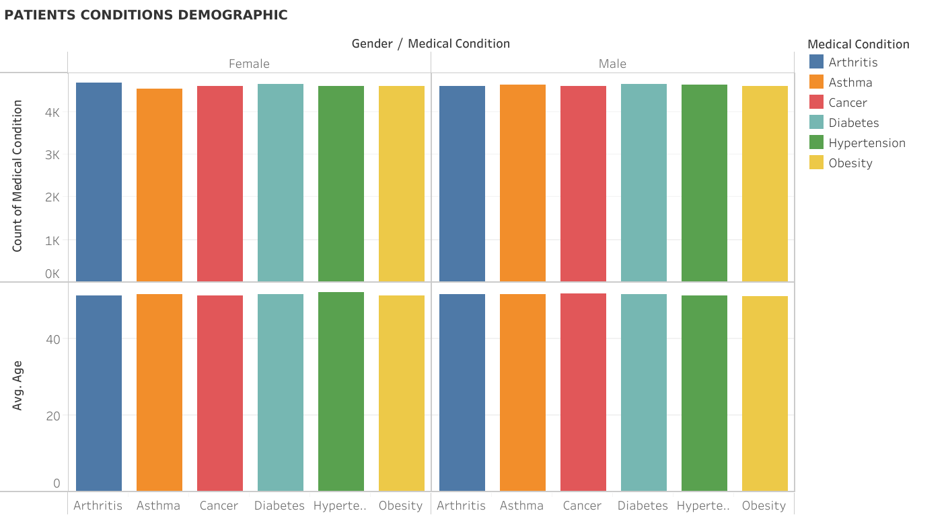

**Apply predictive analytics to predict patient outcomes based on factors such as age, treatment type, and diagnosis. Use regression analysis or decision trees to model the outcomes.**

P-value: N/A

Equation: Count of Medication = 1*Count of Test Results + 0

Coefficients

Term Value StdErr t-value p-value

Count of Test Results 1 0 inf < 0.0001

intercept 0 0 N/A < 0.0001

The model indicates a direct and significant relationship between the count of test results and the count of medication, with every additional test result leading to one more medication prescribed. Given the statistical significance, this relationship is likely not due to random chance.

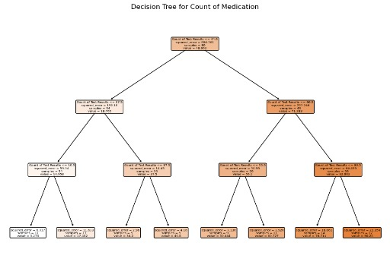

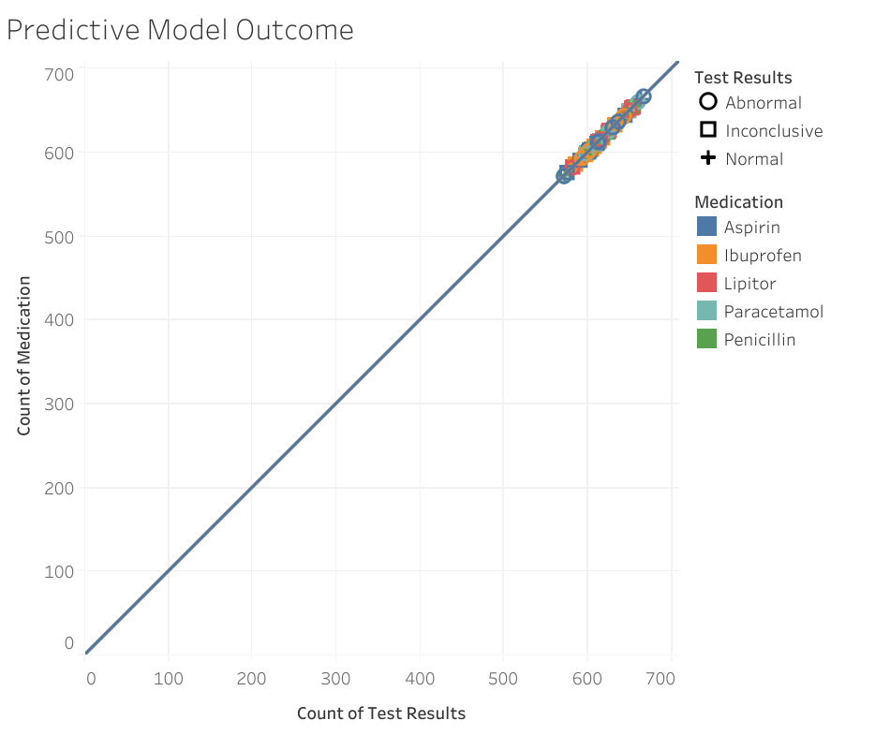

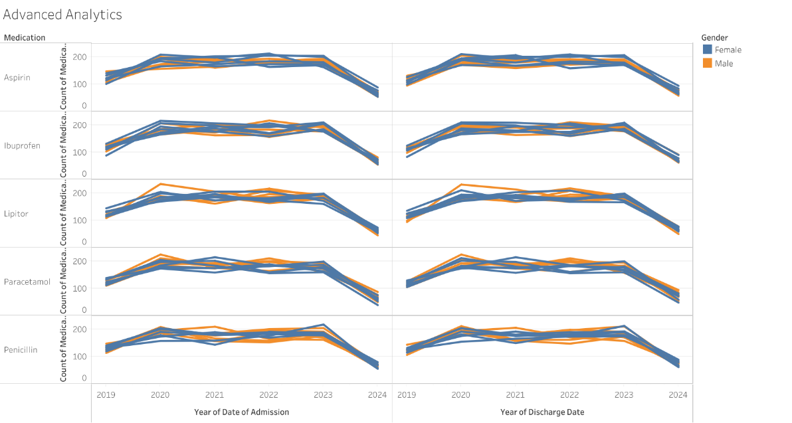

Conclusion

The data and chart show that there is an alarming rate of people with life-threatening diseases. Although they have been treated people are advised to go to their doctor and have a checkup so as to prevent some emergency cases that could be avoided. Drug Prescription is also on the rise for every new patient delivered. Below is a chart that encapsulates the issue described.

